# PROJECT DESIGN PHASE - 1

SOLUTION ARCHITECTURE

|  |  |
| --- | --- |
| Date | 25 October 2022 |
| Team ID | **PNT2022TMID41415** |
| Project Name | **Real-Time River Water Quality Monitoring and Control System** |
| Maximum Marks | 4 Marks |

# SOLUTION ARCHITECTURE:

Solution architecture is a complex process – with many sub-processes – that bridges the gap between business problems and technology solutions. Its goals are to:

* Find the best tech solution to solve existing business problems.
* Describe the structure, characteristics, behaviour, and other aspects of the software to project stakeholders.
* Define features, development phases, and solution requirements.
* Provide specifications according to which the solution is defined, managed, and delivered.





**WIFI/INTERNET**

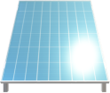

**SOLAR POWERED**

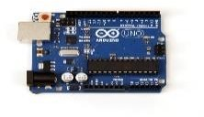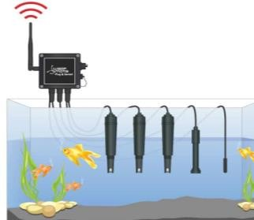





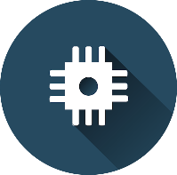IBM CLOUD **USER INTERFACE**

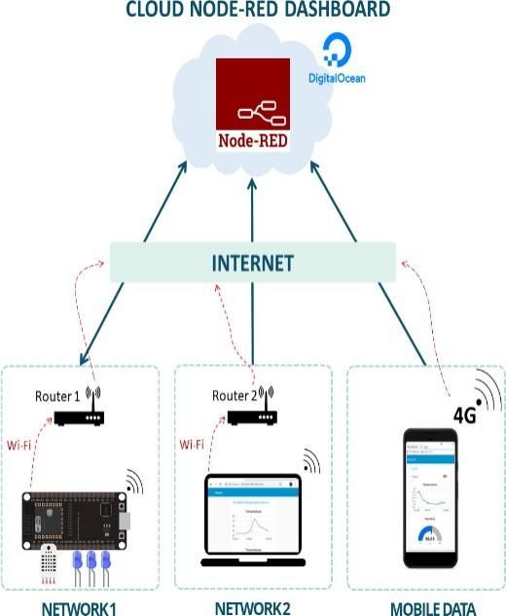

**IOT WATSON PLATFORM**

**MCU**

**REMOTE ACCESS**

**SENSING WATER QUALITY**

**PYTHON RANDOM DATA**

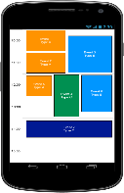**FLASH SMS**

